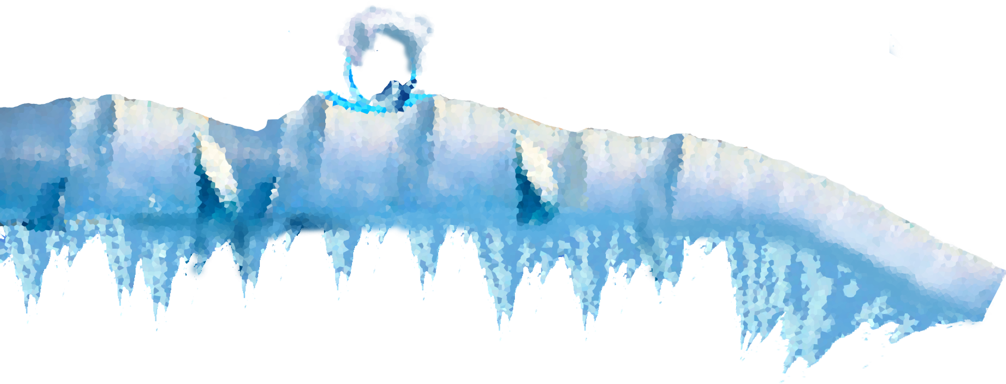

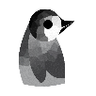

artic

game project

c. Austria & m. Benson

cosc 491

Steven Kennedy

Table of Contents

Project Mechanics…………………………………………..3

Project Aesthetics…………………………………………...4

Project Dynamics……………………………………………

Project mechanics

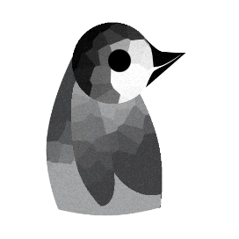

*Example 1.1 Penguin (Order: Sphenisciformes; Name: Spheniscidae)*

This penguin right here will be the Player.

The player’s objective will be to maneuver a treacherous, icy and ‘platformed’ world full of golden fishes to collect and perilous path choices to make. There are platforms with varied heights and water that obstructs the penguin path towards the end of the level.

The goal is to reach the end so the player can continue on toward the eventual goal of learning to fly. The penguin must first make friends with all the other animal groups (not currently implemented) before he reaches the end of his journey.

Move left and right with arrow keys, ‘a’ and ‘d’, or by tilting the device. Jump by pressing the space bar or by tapping the screen, and slide like all good penguins should by pressing down or ‘s’.

The penguin can also swim and has a powerful leap when jumping out of the water that can be used to reach higher areas.

Fish Coins can also be collected by running into them, which increases the player’s score. This score has some future implementation not yet decided.

project aesthetics

The developers incorporated the artic theme (naturally) for the game. After all, what is a penguin without water, ice and snow? The developers decided to go with a crystalized, frost-like look which they believe helps set the mood.

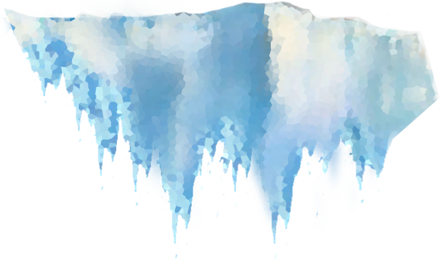

*(Above) Example 2.1 an iceberg concept art.*

The player will also notice that their Camera View blurs the other parts of the scene and focuses only on the area where the penguin is.(See Example 2.2) This serves as an added layer of challenge and decorative aspect to the game. This is what one would see when looking into a frosted window or equally translucent object. The water physics in game also helps in stimulating a water-like environment for the player. Sine waves are used on the line that separates air and water to create a wave effect on the surface. (See Example 2.2)

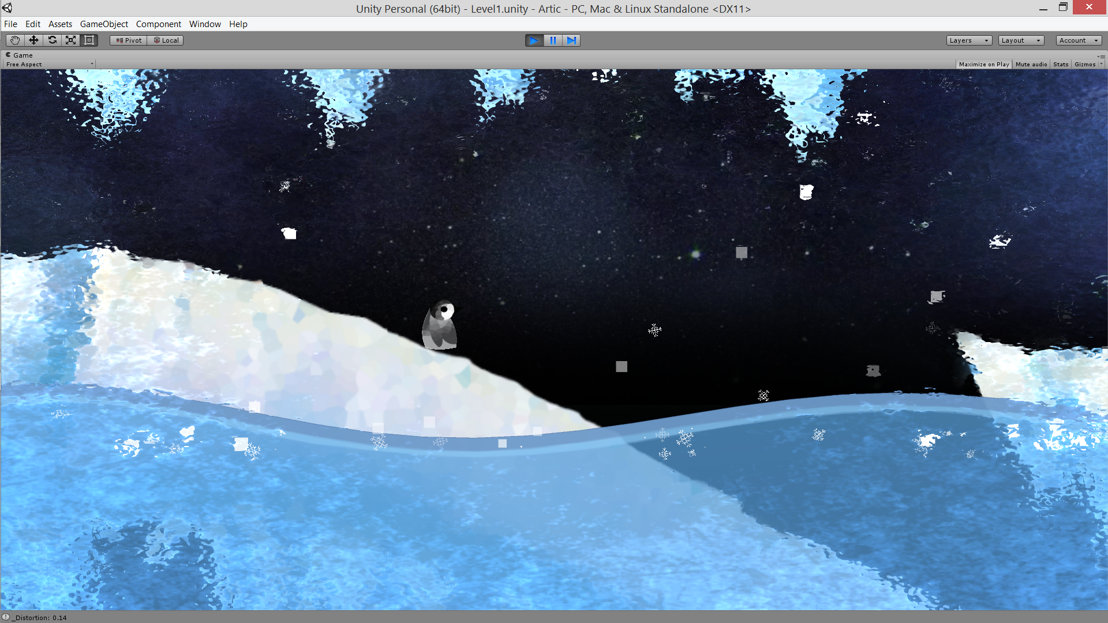

*(Above) Example 2.2 A frosty level in game.*

The fish (although originally conceived to be gray) is coloured yellow to make them a stark contrast to the blue theme background.



*(Above) Example 2.3 Midas’s fish? Maybe. An example of in game collectible.*

This uses the color schema of complementary colors contrasting each other. See Example 2.4.

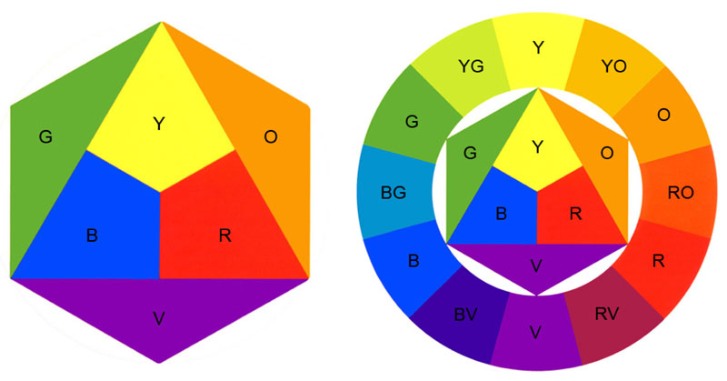

*(Above) Example 2.4 The color wheel.*

The developers also took the time to animate the game background to add more ambiance to the artic theme of the game. The stars in the sky twinkles and light play through parts of the underwater area. Snow is also seen in game with the help of a pixel weather prefab and more.

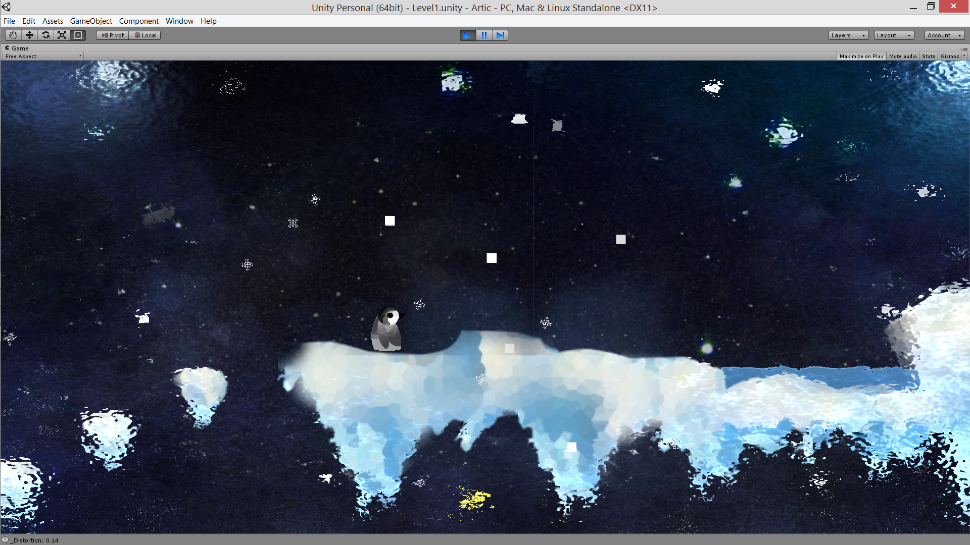

project dynamics